**Project: Getting Started with Web Requests and Bots**

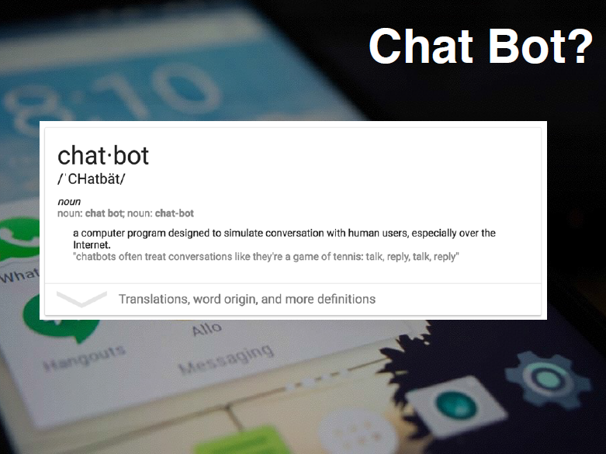

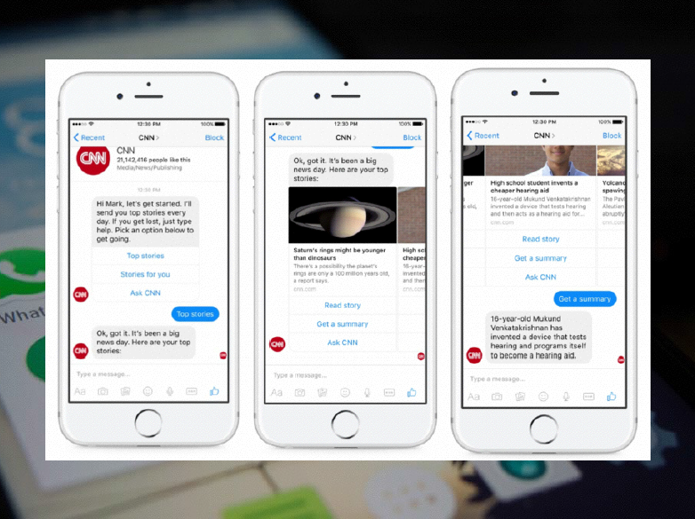

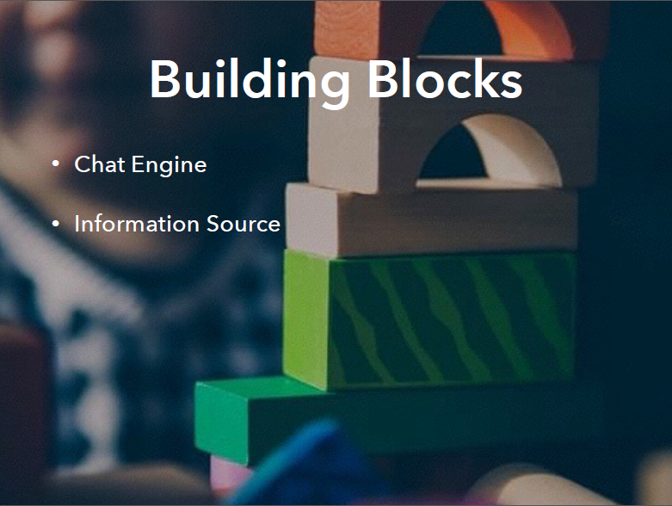

<http://www.jibble.org/pircbot.php>

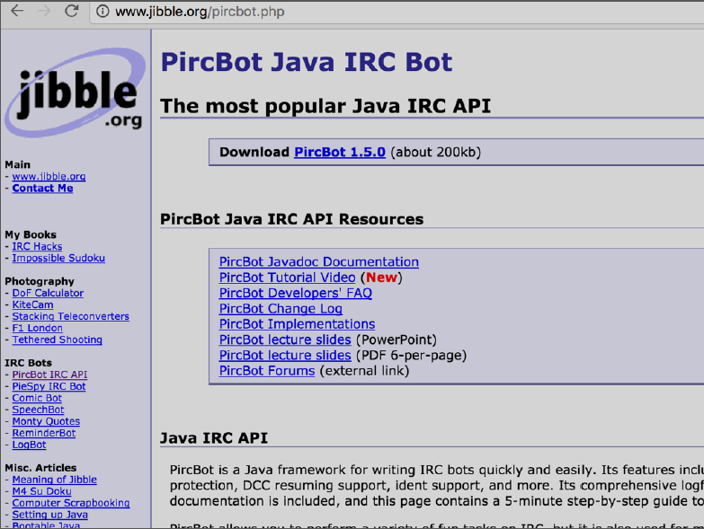

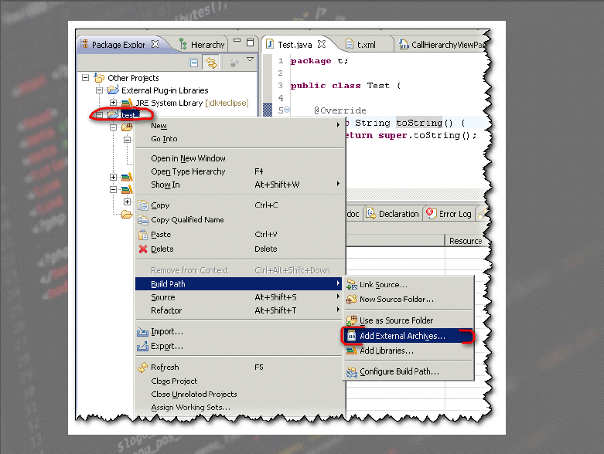

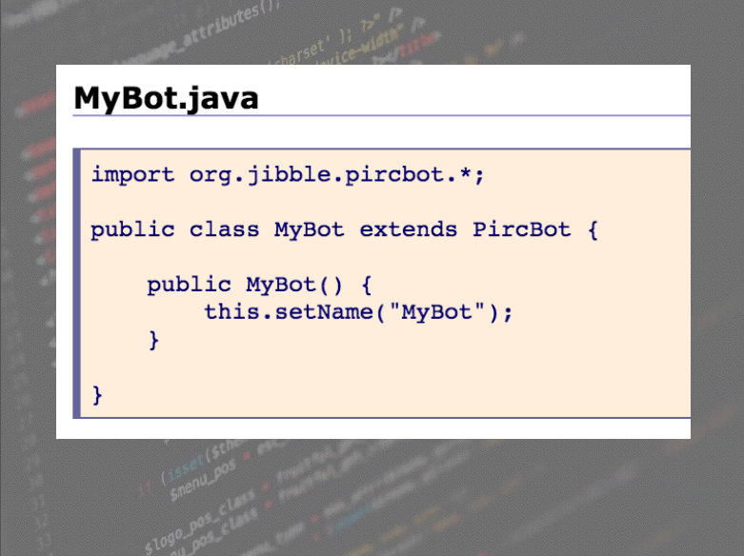

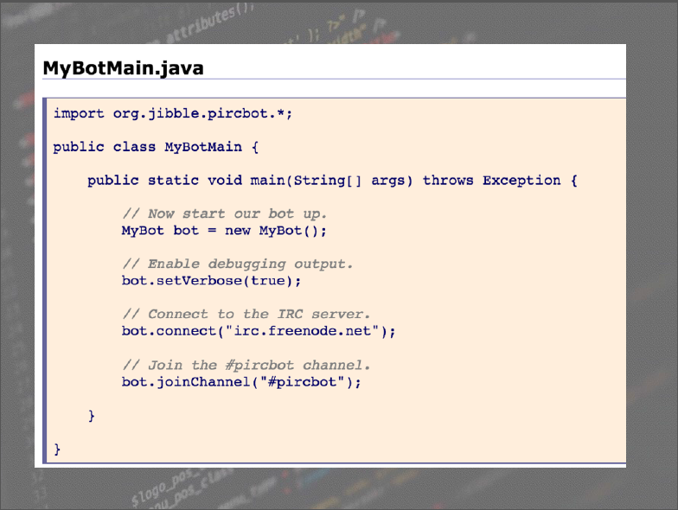

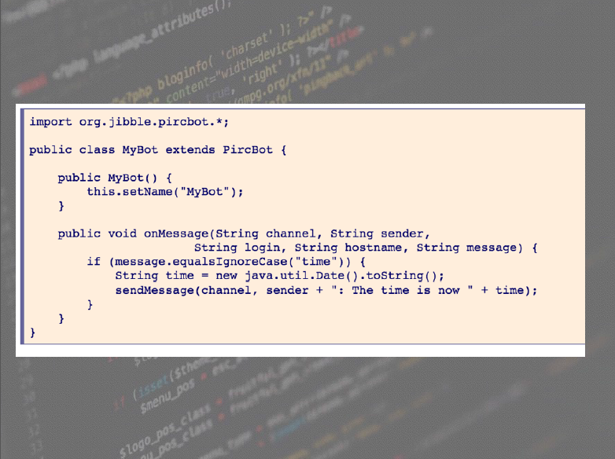

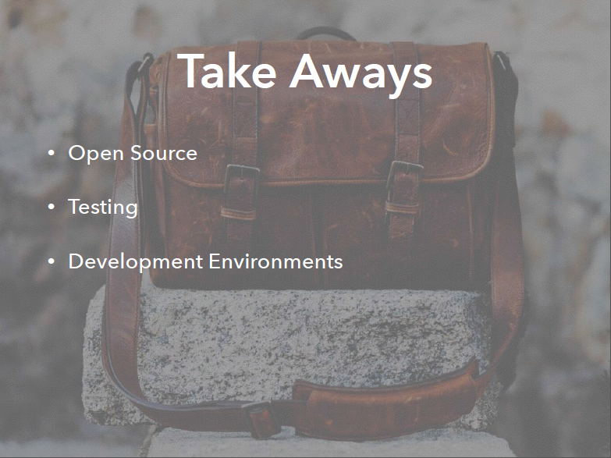

The Project is broken down into the following pieces:

**PART 1 - Making Use of a REST API and Web Requests**

* Make Web Requests to Receive Data (REST), you will need to learn more on what this is.
  + You can use Postman (app) to test requests
  + Twitter
    - Get trending tags
      * <https://dev.twitter.com/rest/reference/get/trends/place>
  + Weather
    - Get Local Temperature
      * <https://openweathermap.org/api>

For example: You can hit a URL like : [api.openweathermap.org/data/2.5/forecast?lat=35&lon=139](http://api.openweathermap.org/data/2.5/forecast?lat=35&lon=139&appid=b1b15e88fa797225412429c1c50c122a1) 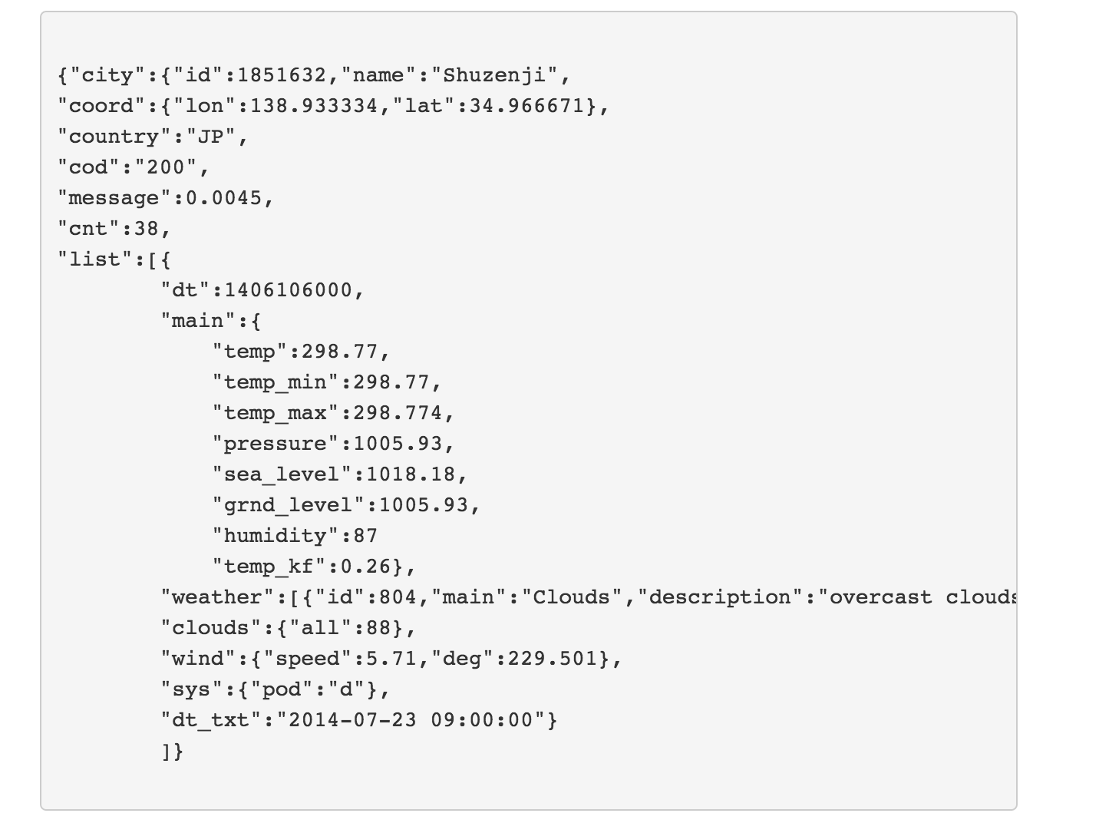

The response format that you get is called JSON (Javascript Object Notation). You will want to read up more on this (<http://codular.com/json>).

A good JSON editor is: <http://www.jsoneditoronline.org/> It can easily parse it and let you understand the JSON.

Your Java Program will need to parse the JSON to make use of the data. You will definitely need to use a library to parse the Json. GSON is a good library to use, look it up on your own.   
  
Use this website for reference:

<http://www.oracle.com/technetwork/articles/java/json-1973242.html>

Ideally, you will want to make a method that you can call in your Java program that return this information to you.   
  
For example a function like:  
  
**int getWeather(string city) ->** returns the current temperature from the Weather API

**PART 2 - Creating a Interfaceable Chat Bot**

You will want to first create a simple program that can connect to the Chat Server. The chatserver we will be using is called FreeNode.  
  
Here is some sample code to s

* Use Java.Net Library to create a Chat Server
  + Directions are provided below
    - You will expose your bot so anyone can interact with it
    - Check next page for code sample

When the bot’s connected to the group chat it should read the messages and when a message matches a command it respond accordingly. This means if someone says “Weather 75080” it should return parse the words and query the weather API and return the information in a IRC-friendly format (“The weather’s going to be X with a high of Y and a low of Z.”

* + Use command phrases that trigger a response
    - “Weather 75080”
    - “How’s the weather in 75080?”
  + Use your wrapper and respond accordingly.
  + It doesn’t have to use Natural Language Processing, keywords is fine

Here is some code to get you started with connecting to a bot on Freenode:  
<http://archive.oreilly.com/pub/h/1966>

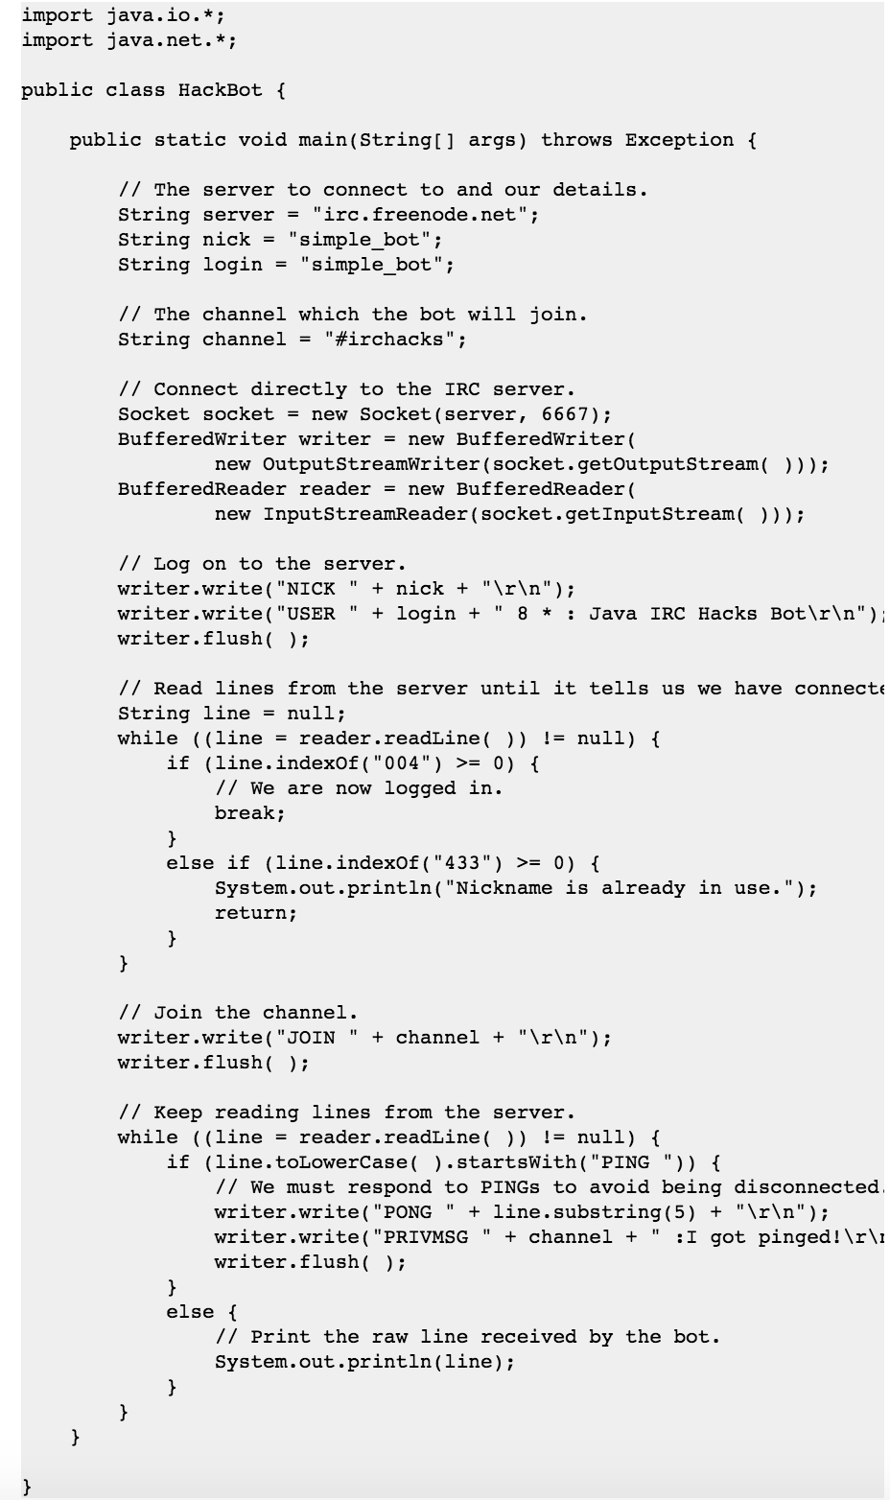

I am trying to get student visitors next week or someone from Makerspace Workshops to review the following with you:

1. **Web Requests in Java**   
   Making REST calls using Java. It will introduce you to how the web works and you will be able to make functions that can fetch data
2. **Building an IRC client**   
   Making an IRC client using Java. This should introduce you to Sockets and be able to connect and interact with an IRC server. You’ll be able to make a functional Hello World bot.